Incubating Rocking Shaker—TRS1000
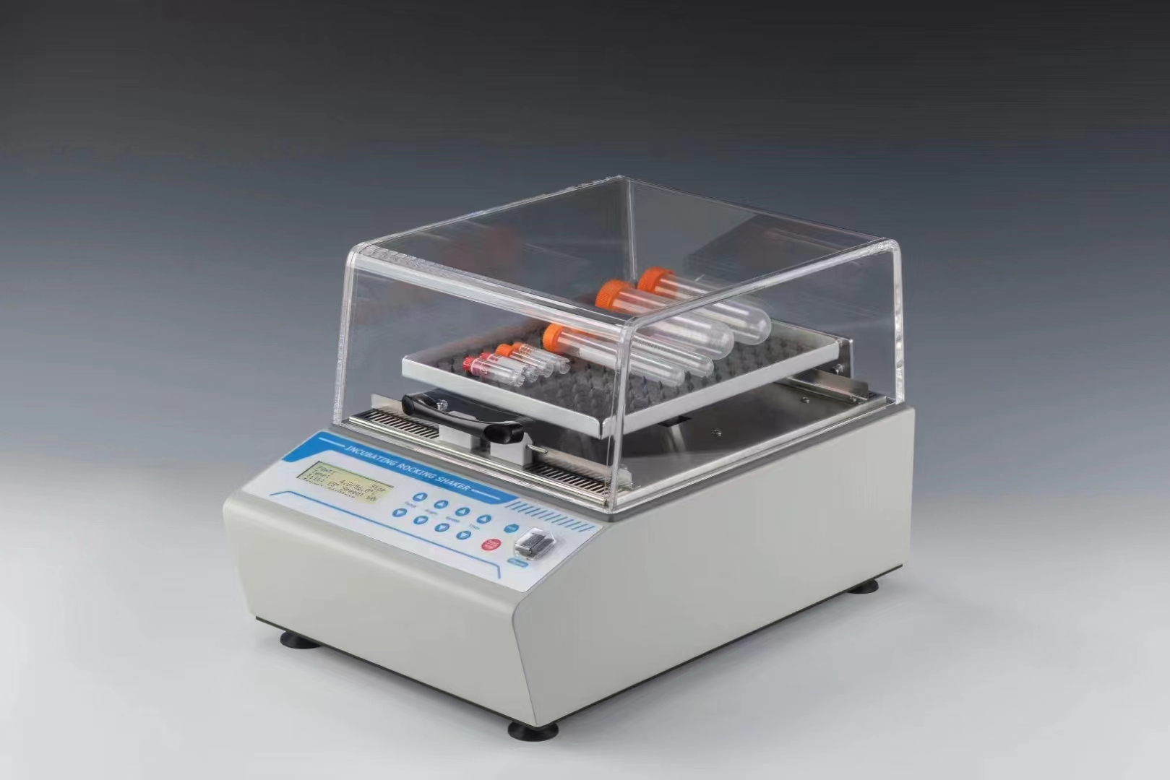
Description:
TRS1000 Incubating Rocking Shaker is a multi-purpose constant temperature rocking shaker which combines step motor and PID intelligent temperature control technology. It is designed to incubate samples from 5°C above ambient to 65°C to provide accurate and repeatable results. The Incubating Rocking Shaker combines smooth rocking motion and general purpose incubation. It is ideal for cell culture work and are designed to be used in a variety of environmental conditions.

Features:
- LCD display for speed, tilt angle, temperature and time.
- See-saw like motion.
- With spill-resistant design, overload protection.
- Step motor: noiseless, less interference and maintenance-free.
- Transparent lid permits viewing samples without disturbing the internal
temperature.
- Support 5 custom procedures, convenient for quick use.
- Beep alarm when operation ends.
- Built-in temperature calibration function.
- Built-in over-heating protection device, safe and reliable.

Parameters:
Model | TRS1000
Temp setting range | 0°C~65°C
Temp control range | RT+5°C~65°C
Time range | 1min~99h59min/∞
Temp accuracy | ≤±0.5°C@37°C
Display accuracy | 0.1°C
Temp uniformity | ≤±0.5°C@37°C
Speed range | 0~60rpm
Motion type | Rocking
Tilt angle | 0-15°
Heating time | ≤20min(from 25°C to 65°C)
Max. load | 5.0kg
Platform material | Aluminum
Platform dimension | 248x188mm
Power supply | 350W
Voltage | AC220V, 50-60Hz
Fuse | 250V 3A Ф5x20
Dimension(mm) | 430x278x270mm
Weight | 11.7kg

